# **Laboratory practice No. 1: Recursion**

|  |  |
| --- | --- |
| **Samuel Ceballos Posada**  Universidad Eafit  Medellín, Colombia  sceballosp@eafit.edu.co | **Pedro Botero Aristizábal**  Universidad Eafit  Medellín, Colombia  pboteroa@eafit.edu.co |

**3) Practice for final project defense presentation**

**3.1** T(n) = T(n - 1) + T(n - 2) + c

**3.2**

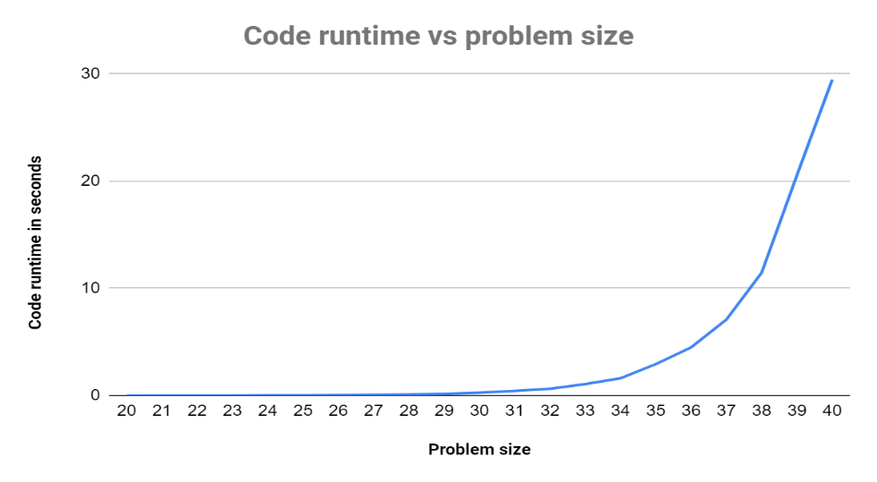

The graph compares the problem size to the amount of time in seconds that it takes to run. We can see an exponential growth in the time as the problem size increases. The runtime when the problem size is 20 or less is instant. Only after 29 we can start to see a noticeable increase in the time.

If the problem size were 50, the code would take approximately 3786.23 seconds (63.1 minutes to run.

**3.3** Taking into account that the containers in Puerto Antioquia are thousands of centimeters long, this algorithm wouldn't be viable because they are way too big. The code would take weeks to run if it were to be used, which would be efficient.

**3.4** …

**3.5** Factorial: T(n)=T(n-1) + C

BunnyEars: T(n)=T(n-1) + C

Fibonacci: T(n)=T(n-1) + T(n-2) + C

BunnyEars2: T(n)=T(n-1) + C

Triangle: T(n)=T(n-1) + C

**3.6** Factorial: n= the answer is the factorial of the number n.

BunnyEars: bunnies= amount of bunnies that we have.

Fibonacci: n= position of the number we are looking for on the Fibonacci series.

BunnyEars2: bunnies= amount of bunnies that we have.

Triangle: Taking into account the fact that each row has one block more than the one on top of it. Rows represent the total amount of rows in the triangle.

The first four problems have the same variables: start, nums and target.

Start= the initial number where the algorithm begins to run .

Nums= the array containing the numbers which the algorithms use to do the operations for the different problems.

Target= the expected result .

The problem splitArray has four variables: start, nums, x and y.

Start= the initial number where the algorithm begins to run .

Nums= the array containing the numbers which will be splitted in two groups.

X=the first group.

Y= the second group.

***4) Practice for midterms***

* 1. *Line 3: return True; Line 4: if(s.charAt(0)==s.charAt(s.length()-1)) {*
  2. *d*
  3. Line 4: int res= solucionar(n-a, a, b, c) + 1; Line 5: res= math.max(res, solucionar(n-b, a, b, c + 1); Line 6: res= math.max(res, solucionar(n-c, a, b, c + 1);
  4. …
  5. Line 3: if(T==0) return 1; Line 4: if(T<0) return 0; Line 8: return f1+f2+f3; Answer: B
  6. Line 10: return suma(n, i+2); Line 12: return (n.charAt(i) – ‘0’) + suma(n, i+1);
  7. …
  8. Line 9: return 0; Line 13: int suma= ni + nj;
  9. …
  10. B
  11. Line 4: return lucas(n-1) + lucas(n-2); Answer: C
  12. Line 13: return 1; Line 17: math.max(fi, fj); Line 18: return sat;